# Explanation for our proposed B2G Feedback Platform.

The proposed B2G Platform will consist of SMS, IVR Voice call, USSD and User Hybrid Mobile Application. To deploy this solution the following are assumed

* Hybrid Mobile Application with unlimited number of subscribers
* Minimum subscription for Incoming and outgoing SMS messages will be 200,000-300,000 subscribers
* IVR Voice call of a minimum of 50,000 Subscription purchases.
* USSD reverse billing sessions with a minimum of 500,000 to 1 M subscriptions

User mobile Application [Called ”SLB2G Survey”] can be downloaded from Play store and Google store. The downloaded app will fetch questions from the mobile application platform. Upon completion of the survey, the survey results will be pushed directly to the platform using API.

BITC will provide 4 staff members who will each be equipped with Samsung tablets. These devices will be running Hybrid mobile applications that will conduct the survey. The staff members will assist technically challenged and illiterate individuals to participate in the survey. The staff members will be engaged in this activity for the duration of the project [30 working days]

The stakeholders will have access to a standard web application, which can be logged in remotely. Upon login, users will be presented with a dashboard view of the surveys being conducted. They may generate on-demand graphical reports based on the survey for quick analysis.

The application has been future proofed such that if the SL chamber of commerce wishes to conduct similar surveys in the future, they may use the platform to create new surveys. The platform will be configured to create as many surveys as needed in the future at no extra cost to the “SL chamber of commerce”.

*The application as well as source code will be the sole property of “SL chamber of commerce”*

Please find below a brief explanation as well as infographic that explains our solution

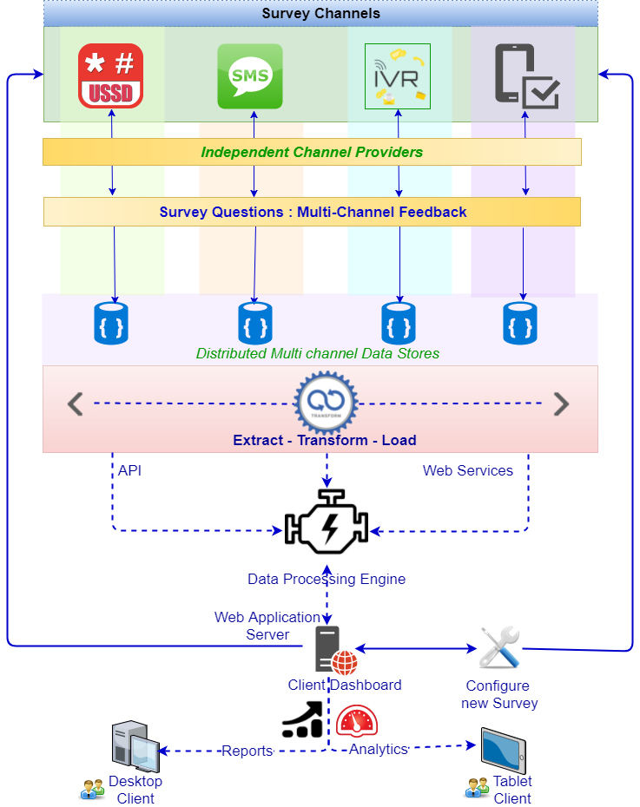

* Surveys are served to the consumers via multiple communication channels i.e. via IVR, Mobile phones, SMS & USSD
* Consumers respond to these surveys through vendor independent communication channels
* The results of the survey may be stored in independent channel stores.
* Since respondents can respond to a single survey using multiple channels, the results of the survey may be distributed across multiple channel databases
* The information in these disparate databases shall be combined using an appropriate extract-transform and load strategy
* The transformed results maybe fed into a data processing engine
* The engine may access the data using application services or API’s provided by the data providers.
* The processing engine then serves the data via a web server and makes it available to the stakeholders
* Stakeholders access the data by logging into the web application via tablets or a desktop
* The application will have dashboards and reports that will be capable of slicing and dicing the data from one or more surveys
* A web backend will also be available to the stakeholders to create new surveys. New surveys can then be made available to respondents who may participate using their mobile devices

Warm Regards,

Ayanle Jama